1 (a) (i) Define the speed of an object.
..…..…………………………………………………………………………………

(ii) Distinguish between speed and velocity.

..…..…………………………………………………………………………………

..…..…………………………………………………………………………………
[3]

(b) A boat moves forwards at 10.0 ms⁻¹. You walk across the deck at 1.5 ms⁻¹ at an angle of 30º as shown in figure below.

10.0 ms⁻¹
1.5 ms⁻¹
30º
10.0 ms⁻¹

- What is the forward component of your velocity relative to the boat?

- What is your total forward velocity?

[4]
2 (a) State two conditions for an object to be in equilibrium.

1. ..…..…………………………………………………………………………………

..…..…………………………………………………………………………………

2. ..…..…………………………………………………………………………………

..…..…………………………………………………………………………………
[2]

- A uniform plank is 3.0 m long and weighs 200N. Two people, A and B, are carrying it. A is 0.1 m from one end and B is 1.0 m from the other end.

- Draw a force diagram of the plank.

[2]

- Who takes the most weight? Show your workings below.

[3]

[Turn Over
3. (a) Define the following.

- Density

…………………………………………………………………………………………..

- Pressure

…………………………………………………………………………………………..
[2]
- Derive from the definitions of density and pressure, the equation p =ρgh for the pressure exerted by a column of liquid of height h and density ρ.

[3]
(c) A vessel, containing a liquid of density ρ, moves vertically upwards with an acceleration a.

- Find the variation of the pressure p with the depth h below the liquid surface.

- Find the variation of the pressure p with depth h if the vessel moves downwards with an acceleration a.

- Find the variation of the pressure p with depth h when the vessel is in free fall.

[6]

4. (a) Define power.

…………………………………………………………………………………[1]

- A manufacturer claims that the maximum power delivered by the engine of a car of mass 1500 kg is 100 kW. Find the minimum time in which the car could accelerate from rest to 60 ms⁻¹.

t = …………………….s [3]

- An independent test quotes that the car accelerates from rest to 60ms⁻¹ time of 35 s. Suggest a reason for the difference from the time you have calculated.

………..……………………………………………………………………………

…………………………………………………………………………………...[1]

[Turn Over
5. The figure below shows the strain produced when two different materials are put
under increasing stress until they break. One of the materials described as brittle and
the other as ductile.

strain
stress
A
B

- ( i ) State which material has the higher Young Modulus, explaining your
reasoning.

…………………………………………………………………………………

…………………………………………………………………………………

………………………………………………………………………………...
[3]

( ii ) Explain the meaning of brittle and ductile.

Brittle : ……………………………………………………………………

……………………………………………………………………

Ductile : ……………………………………………………………………

……………………………………………………………………
[2]

(b) Indicate which material is the brittle material and which is the ductile material.

Material A : ………………………………………..

Material B : .……………………………………….

[2]
6. Figure below shows the variation with time t of the displacement x of a particle in a
medium as a result of the passage of a transverse wave T₁, through the medium.
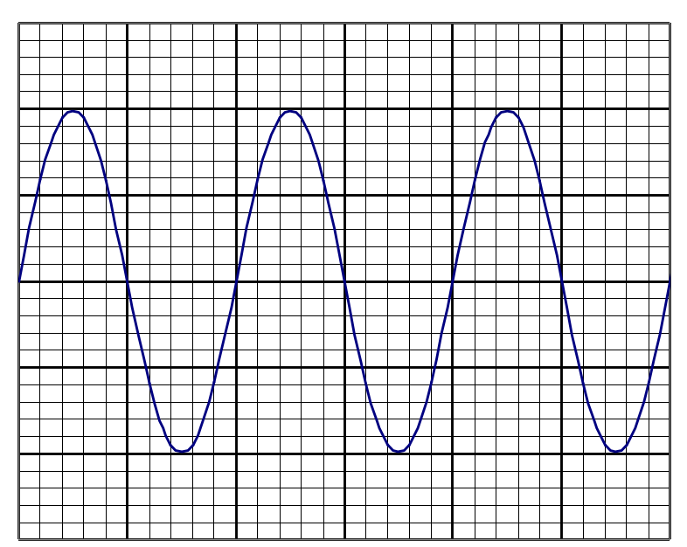
10
t/ms
5

The transverse wave T₁ has intensity I. It causes the particles to oscillate with
amplitude A. A second similar transverse wave T₂ has the same frequency but the
amplitude of oscillation due to T₂ alone is 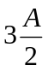.

(a) State what is meant by a transverse wave.
…………………………………………………………………………………………

…………………………………………………………………………………………

……………………………………………………………………………………... [2]

(b) Calculate
(i) the frequency of the waves,

frequency =……………………Hz

[Turn Over
(ii) the intensity, in terms of I, of the wave T_{2.}

Intensity =………………………..
[4]
(c) State two conditions which are necessary for the two waves T₁ and T₂ interfere
destructively.

1…………………………………………………………………………………

2…………………………………………………………………………………

[2]

(d) Calculate, in terms of I, the intensity of the resultant wave when T₁ and T₂ interfere
destructively.

Intensity =………………. [2]

7. The figure below contains a component Y in parallel to a thermistor.

Y
2 Ω
+
−
125 Ω
50 Ω

(a) At a particular temperature, the potential difference (p.d) across Y is 5.00 V. The
resistances of component Y and thermistor are 125 Ω and 50.0 Ω respectively.
Calculate

(i) the total resistance of the circuit

(ii) the p.d across the power supply

[5]

- Suggest why the resistance of the thermistor decreases with increasing p.d.

…………………………………………………………………………………

…………………………………………………………………………………

……………………………………………………………………………… [1]

[Turn Over

8.(a) Two isotopes of Tin are Tin – 112 and Tin – 115. The proton number of Tin is 50.

- Explain what is meant by isotopes.

……………………………………………………………………………………..

……………………………………………………………………………………..

……………………………………………………………………………………..

(ii) Write down the nuclear representation of these two isotopes.

______ ______
Tin Tin
______ ______

[4]

(b) Nitrogen nuclei when bombarded with α-particles, may undergo a nuclear
transformation.

One such transformation is

14 _{N +} 4 _{He} 17 _{O +}
7 2 8 ________

(i) Complete the equation for this transformation.

(ii) Identify the particle other than the oxygen nuclide in the transformation.

……………………………………………………………………………………..

……………………………………………………………………………………. [3]

